Blockbuster output

June 2018

# Model parameters

The following outputs are from a Blockbuster Deterioration model run over 10 years. A summary of the model parameters in provided below, but full details can be found in the accompanying **Excel input.xlsm** file.

|  |  |
| --- | --- |
| Parameter | Value |
| Inflation on repair and rebuild costs | yes |
| Block rebuild unit cost | 2000 |
| Repair order | EDCB |

## 

The yearly budgets available for rebuilding and repairing are:

|  |  |  |
| --- | --- | --- |
| Year | Repair.budget | Rebuild.budget |
| 1 | £0 | £0 |
| 2 | £0 | £0 |
| 3 | £0 | £0 |
| 4 | £0 | £0 |
| 5 | £0 | £0 |
| 6 | £0 | £0 |
| 7 | £0 | £0 |
| 8 | £0 | £0 |
| 9 | £0 | £0 |
| 10 | £0 | £0 |

# Model results

## Expected backlog per year

|  |  |  |  |
| --- | --- | --- | --- |
| Year | Backlog | Year on year change | Previous year’s investment in estate |
| 0 | £3.3B | NA | NA |
| 1 | £7.2B | £3.9B | 0 |
| 2 | £12B | £4.9B | 0 |
| 3 | £18B | £5.4B | 0 |
| 4 | £23B | £5.5B | 0 |
| 5 | £29B | £5.5B | 0 |
| 6 | £34B | £5.4B | 0 |
| 7 | £39B | £5.3B | 0 |
| 8 | £44B | £5.1B | 0 |
| 9 | £49B | £4.9B | 0 |
| 10 | £54B | £4.6B | 0 |

## Expected backlog per year

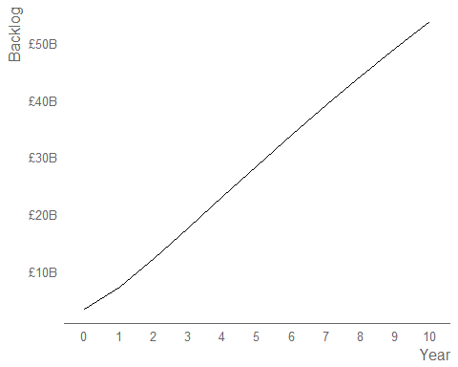

## Expected backlog by condition grades

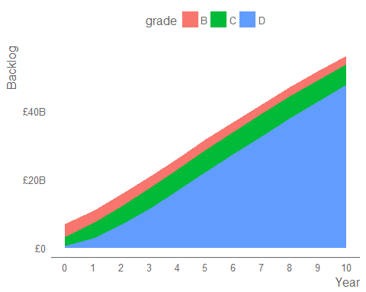

## Yearly change in expected backlog

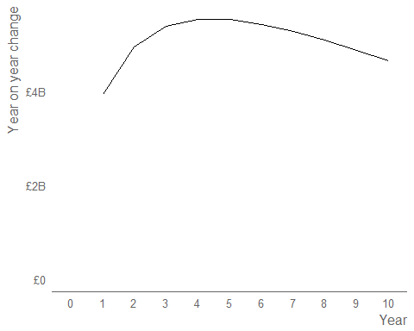

## Expected proportion by condition grades

